Create And Configure IBM Cloud Service Create Node-RED Service

|  |  |
| --- | --- |
| **Date** | **09 November 2022** |
| **Team ID** | **PNT2022TMID48656** |
| **Project Name** | **loT Based Safety Gadget For Child Safety Monitoring & Notification** |
| **Maximum Marks** | **4 Marks** |

# AIM

To Create Node-RED service.

# STEPS

1. Login to IBM Cloud with mail ID and Password.

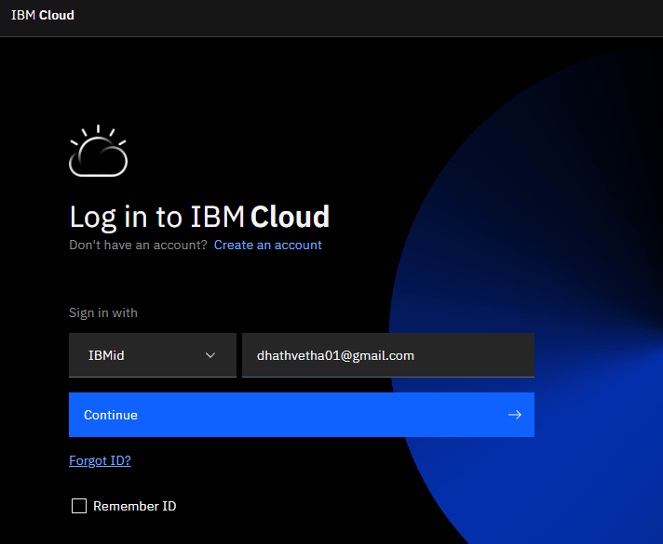

2.Go to Catalog and Search for Node-red App in the search bar

.

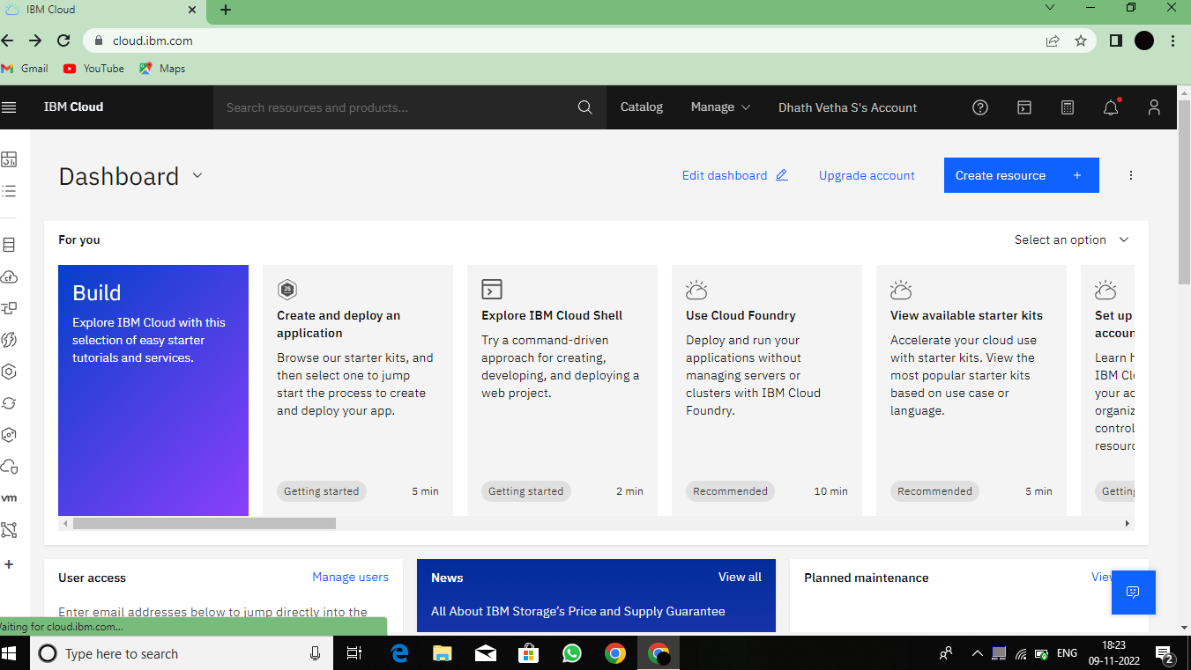

3.In next step, App URL is created

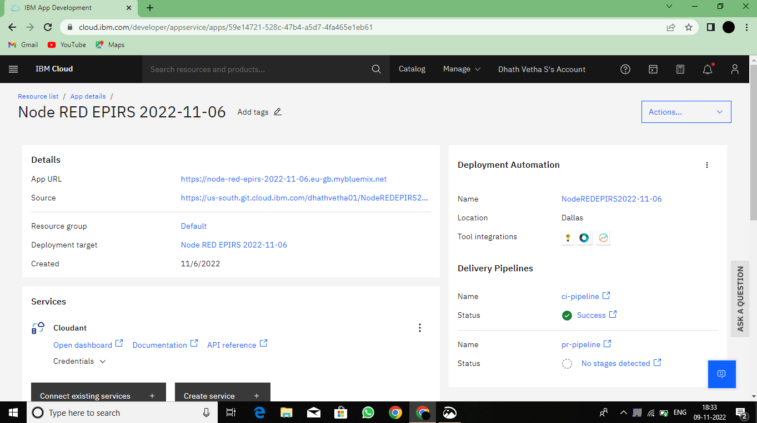

4. Successfully creating the app

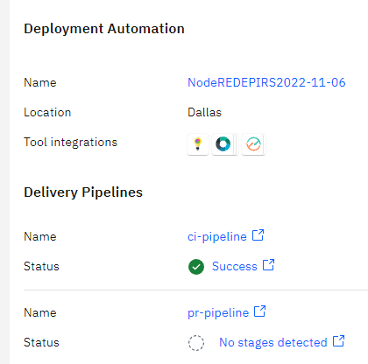

5.By clicking the URL node red page will come

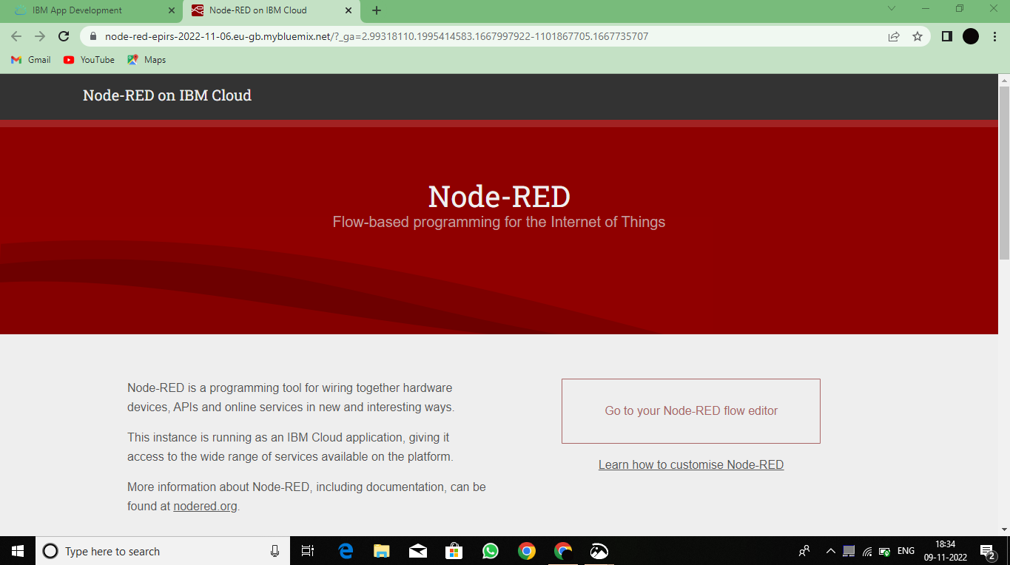

6.And it works successfully

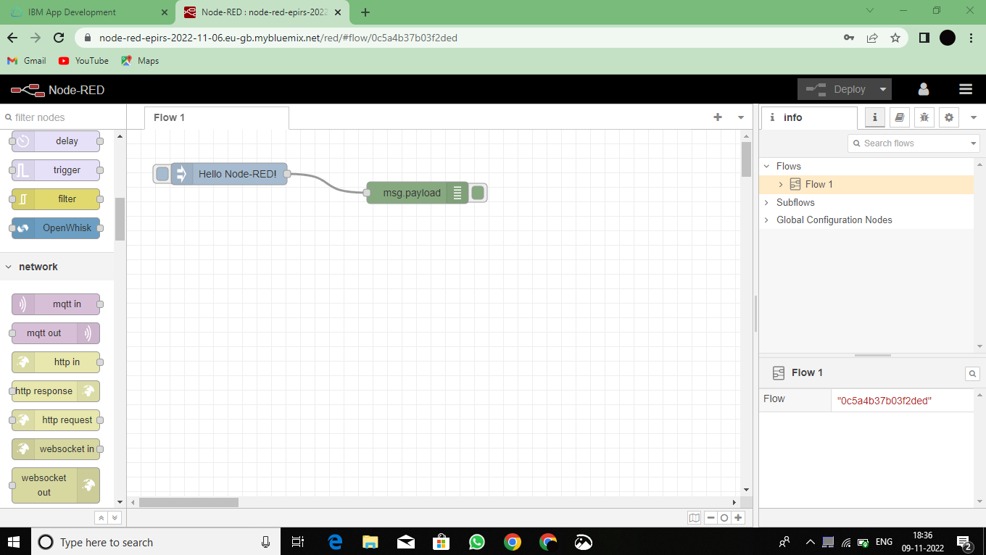

**RESULT**:

Successfully created the Node-RED service.

## TEAM ID : PNT2022TMID48656 TEAM LEADER : A.AFRIN SHIFANA

## TEAM MEMBER 1 : S.DHATH VETHA

**TEAM MEMBER 2 : P.SNEHA**

**TEAM MEMBER 3 : M.KEERTHI**

## TEAM SIZE 4

## MENTOR : C.KANNIKA PARAMESHWARI